**Module 3: IBM Python Assignment**

|  |  |
| --- | --- |
| Assignment Date | 19 September 2022 |
| Student Name | Poovizhi P |
| Student Roll Number | 311019104058 |
| Maximum Marks | 4 Marks |

**1.** Consider a list (list = []). You can perform the following commands:

insert i.e.: Insert integer at position.

print: Print the list.

remove e: Delete the first occurrence of integer.

append e: Insert integer at the end of the list.

sort: Sort the list.

pop: Pop the last element from the list.

reverse: Reverse the list.

Initialize your list and read in the value of followed by lines of commands where each command will be of the types listed above. Iterate through each command in order and perform the corresponding operation on your list.

**Solution:**

theList=[71,25]

# insert integer at specific position

theList.insert(0,5)

theList.insert(1,7)

theList.insert(2,56)

theList.insert(3,45)

theList.insert(2,1)

theList.insert(5,7)

theList.insert(6,89)

print('List: ',theList)

# removing the first occurrence of 7

theList.remove(7)

print('After removing the first occurrence of the 7: ',theList)

# append the element 8

theList.append(8)

print('After append the element 8: ',theList)

# sort the list

theList.sort()

print('After sorting the list: ',theList)

# pop the last element of the list

theList.pop()

print('After pop the last element: ',theList)

# reverse the list

theList.reverse()

print('After reverse the list: ',theList)

**Output:**

List: [5, 7, 1, 56, 45, 7, 89, 71, 25]

After removing the first occurrence of the 7: [5, 1, 56, 45, 7, 89, 71, 25]

After append the element 8: [5, 1, 56, 45, 7, 89, 71, 25, 8]

After sorting the list: [1, 5, 7, 8, 25, 45, 56, 71, 89]

After pop the last element: [1, 5, 7, 8, 25, 45, 56, 71]

After reverse the list: [71, 56, 45, 25, 8, 7, 5, 1]

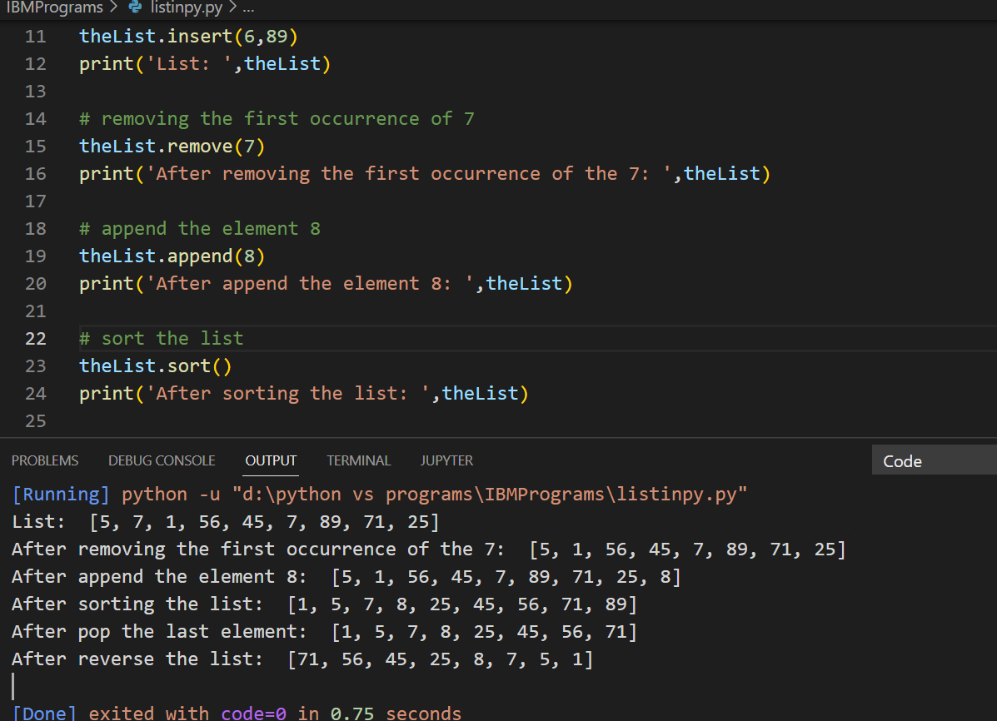

2. Write a Calculator program in Python?

**Solution:**

# Calculator program

def add(x, y):

return x + y

def subtract(x, y):

return x - y

def multiply(x, y):

return x * y

def divide(x, y):

return x / y

print("1.Add")

print("2.Subtract")

print("3.Multiply")

print("4.Divide")

while True:

choice = int(input("Enter Your Choice To Perform Calculation: "))

if choice>0 and choice<=4:

num1 = float(input("Enter first number: "))

num2 = float(input("Enter second number: "))

if choice == 1:

print('The Result: ', add(num1, num2))

elif choice == 2:

print('The Result: ', subtract(num1, num2))

elif choice == 3:

print('The Result: ', multiply(num1, num2))

elif choice == 4:

print('The Result: ', divide(num1, num2))

continue_next= input("Do you want to continue? (yes/no): ")

if continue_next != "yes":

break

else:

print("Invalid Input")

**Output:**

1.Add

2.Subtract

3.Multiply

4.Divide

Enter Your Choice To Perform Calculation: 1

Enter first number: 7

Enter second number: 3

The Result: 10.0

Do you want to continue? (yes/no): yes

Enter Your Choice To Perform Calculation: 1

Enter first number:

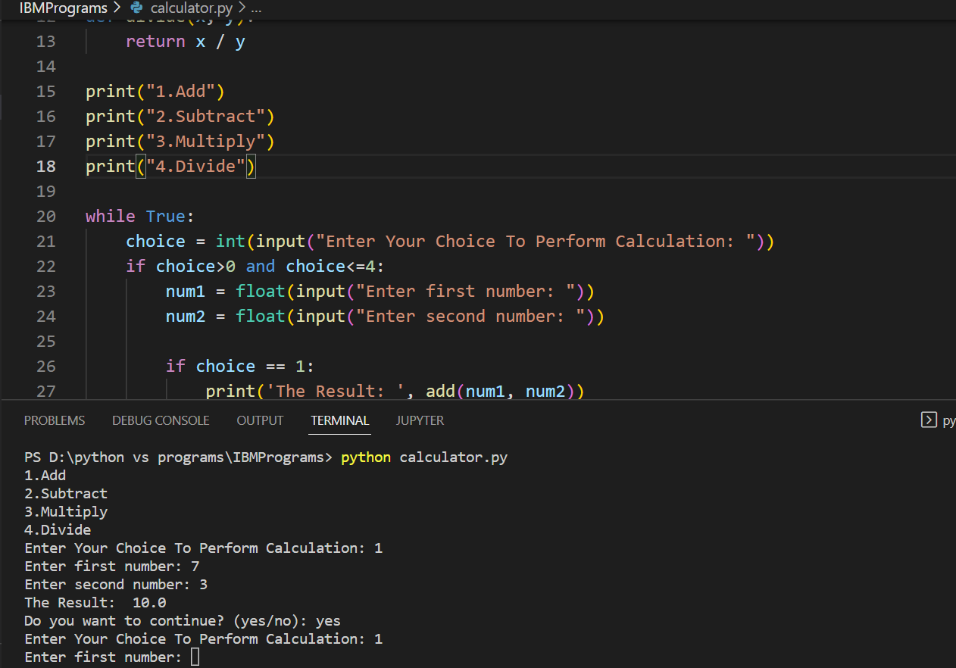

3. Write a program to concatenate, reverse and slice a string?

**Solution:**

#reverse a string

word='python Programming Language'

reversedWord=''

index=len(word)

while index>0:

reversedWord=reversedWord+word[index-1]

index=index-1

print(reversedWord)

#concatenate a string

firstString='Python is a '

secondString='Popular Programming Language'

concatenateString=firstString+secondString;

print(concatenateString)

print('Concatenate the strings using join method : ',''.join([firstString,secondString]))

#slice a string

slicedString=secondString[4:11]

print(slicedString)

**Output:**

egaugnaL gnimmargorP nohtyp

Python is a Popular Programming Language

Concatenate the strings using join method : Python is a Popular Programming Language

lar Pro

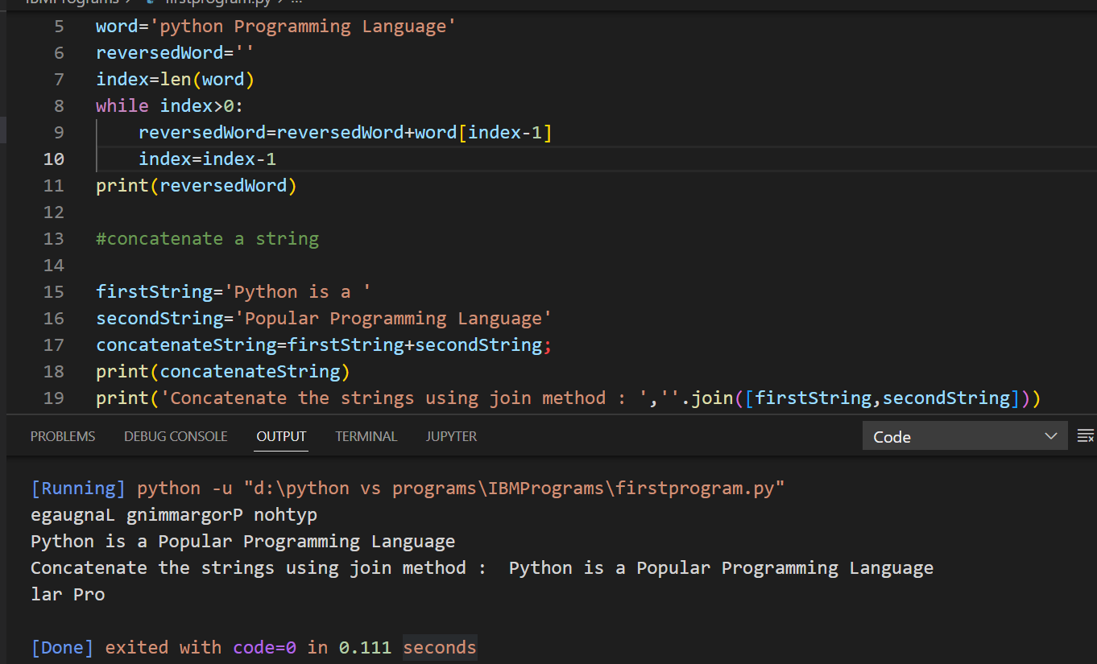

4. Why is Python a popular programming language?

**Solution:**

* Python is a popular programming language. It is an open source.
* It is easy to use and learn for the beginners. It has easily understandable and simple syntax.
* Python also provides large number of advance libraries and packages which makes the work of developers easy and fast. It has a highly supportive community.
* It is widely used in web development, data science, Machine learning, etc.

5. What are the other Frameworks that can be used with python?

**Solution:**

* Bottle
* Flask
* Django
* Web2py
* AIOHTTP
* CherryPy
* Dash
* Falcon
* Growler
* UvLoop
* Pyramid
* Sanic
* CubicWeb
* TurboGears
* Hug
* MorePath

6. Full form of WSGI?

**Solution:**

* WSGI Stands for Web Server Gateway Interface
* **WSGI**is a specification that describes the communication between **web servers and Python web applications or frameworks**.
* It explains how a web server communicates with python web applications/frameworks and how web applications/frameworks can be chained for processing a request.